Question -3

Code:
class question1 {

public static void main (String[] args) {

System.out.println("Hello World");
}
}
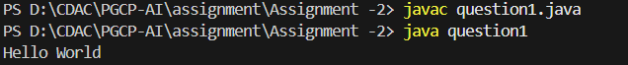

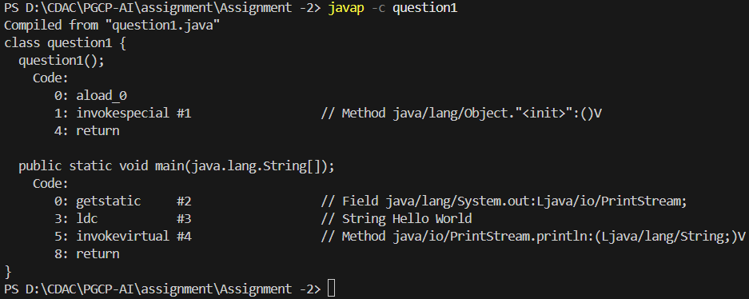

Question -6

Code:
class question2 {
public static void main (String[] args){
boolean value = true;
String output = Boolean.toString(value);

System.out.println(output);
}
}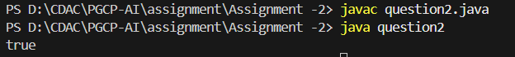
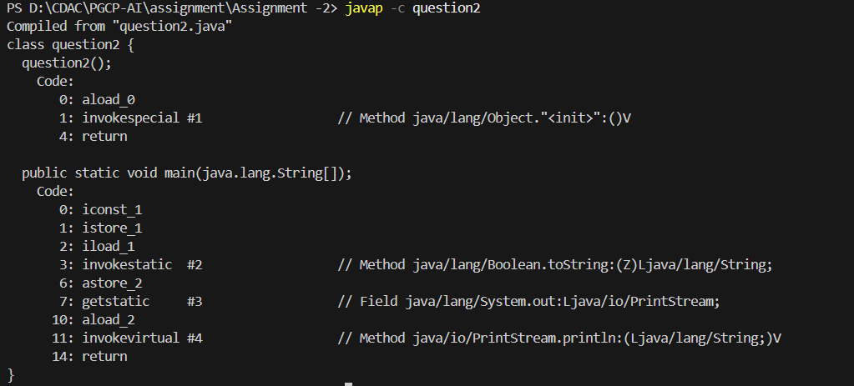

Code:
class question3 {
public static void main(String[]args){
String name = "Priyansu";
Boolean output = Boolean.parseBoolean(name);

System.out.println(output);
}
}
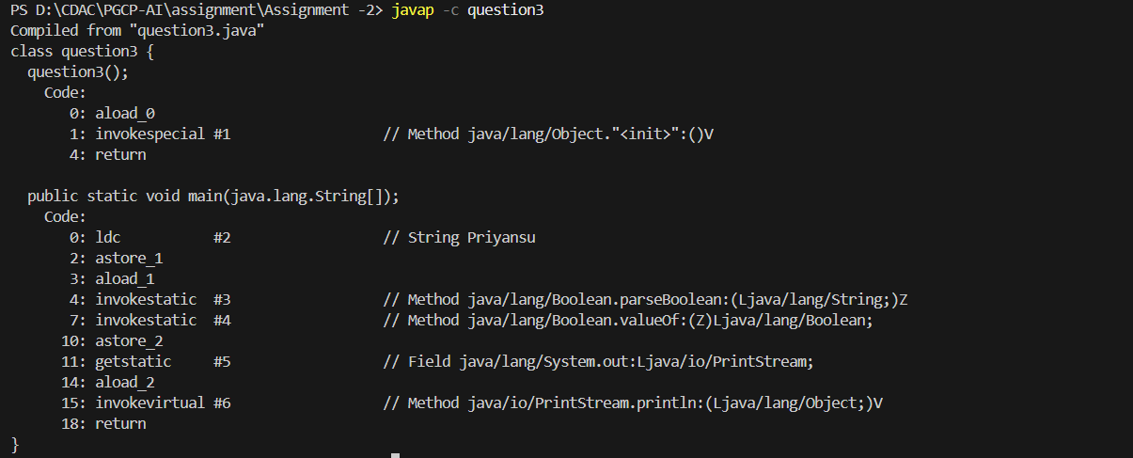

Question 7:

Code:
class question4 {
public static void main(String[ ]args){

int bitsvalue = Byte.SIZE;

System.out.println(bitsvalue);

}
}
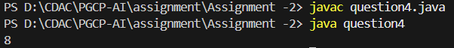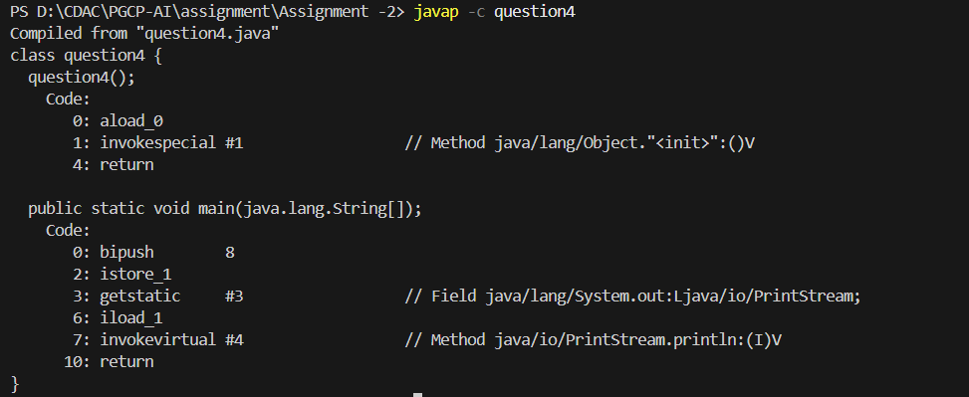

Code:
public class question5 {
public static void main (String [] args)
{
int bytevalue = Byte.BYTES;

System.out.println(bytevalue);
}
}

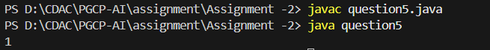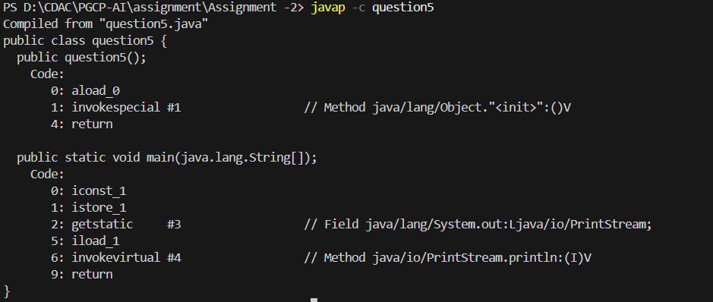

Code:
class question6 {
public static void main(String[ ] args)
{
int min = Byte.MIN_VALUE;

System.out.println(min);

}

}

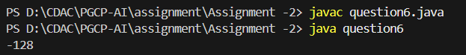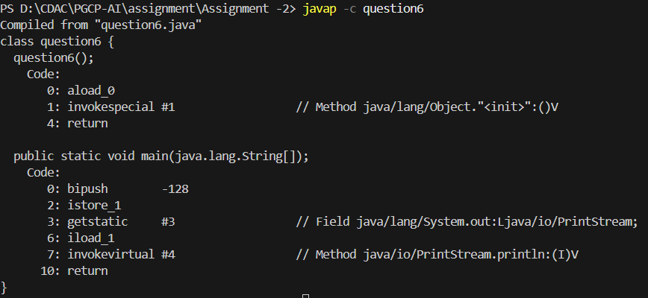

Code:
class question7 {
public static void main(String[] args){
int max = Byte.MAX_VALUE;

System.out.println(max);
}
}

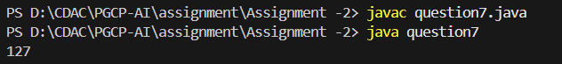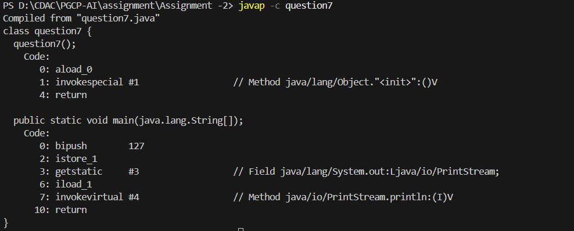

Question10:

Code:
class question8 {

public static void main (String[] args){
int bitschar = Character.SIZE;
int bytechar = Character.BYTES;

System.out.println(bitschar);
System.out.println(bytechar);

}

}

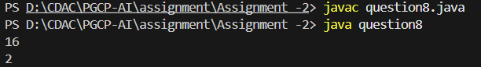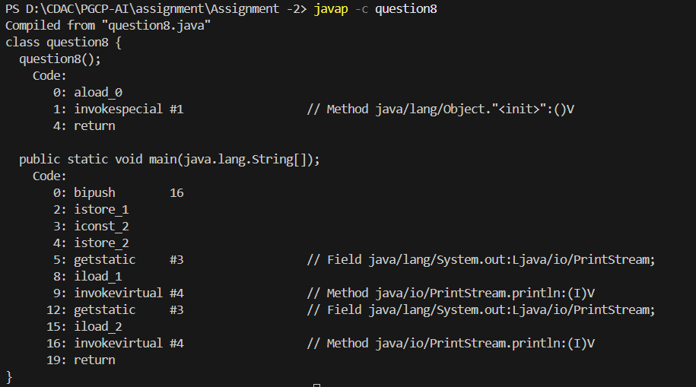

Code:
class question9 {

public static void main(String[] args){
int char_min = Character.MIN_VALUE;
int char_max = Character.MAX_VALUE;

System.out.println(char_min);
System.out.println(char_max);
}

}

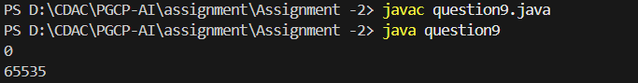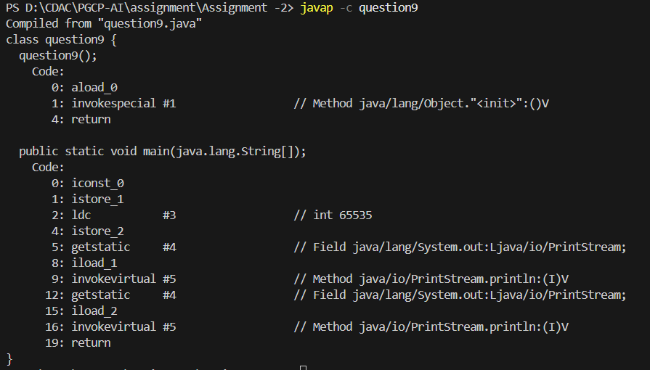

Question 12:
Code:
class question10 {
public static void main(String[] args){
int bits = Short.SIZE;
System.out.println(bits);
int bytes = Short.BYTES;
System.out.println(bytes);
int minimum = Short.MIN_VALUE;
System.out.println(minimum);
int maximum = Short.MAX_VALUE;
System.out.println(maximum);
}
}

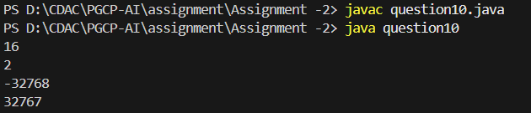

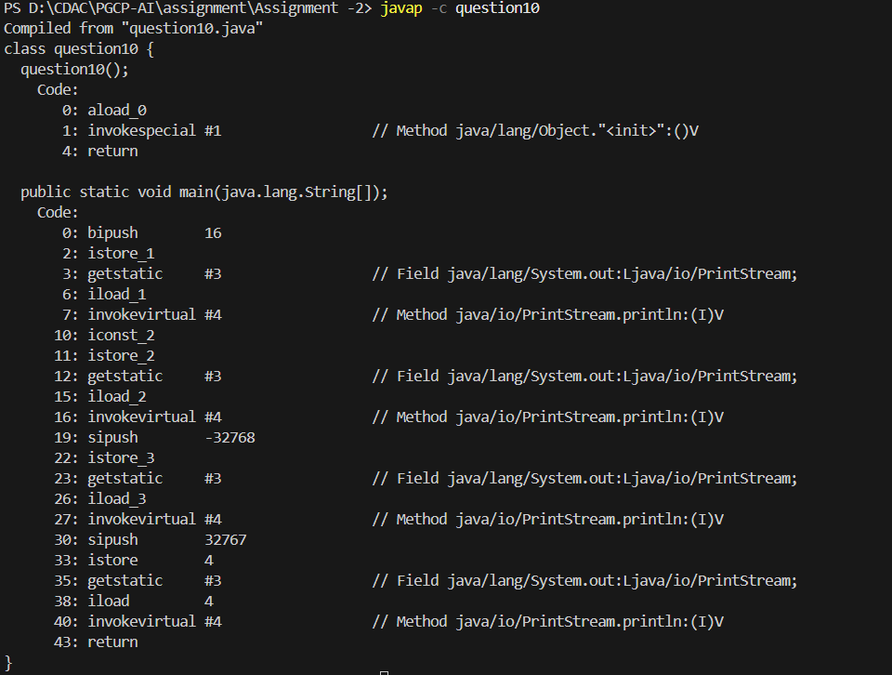

Question 13:
Code:
class question11 {
public static void main (String[] args){

short num = 59;
String s = Short.toString(num);

System.out.println(s);

}
}
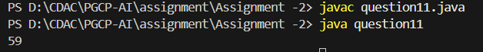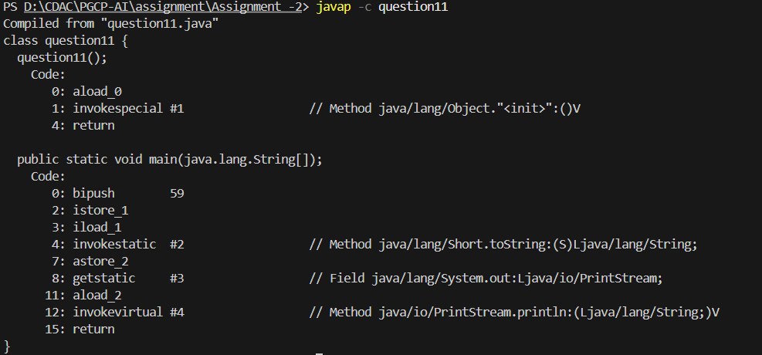

Question 15:
Code:
class question12 {

public static void main (String[] args){

int bits = Integer.SIZE;

System.out.println(bits);

int bytes = Integer.BYTES;
System.out.println(bytes);

int min_value = Integer.MIN_VALUE;
System.out.println(min_value);

int max_value = Integer.MAX_VALUE;
System.out.println(max_value);

}
}
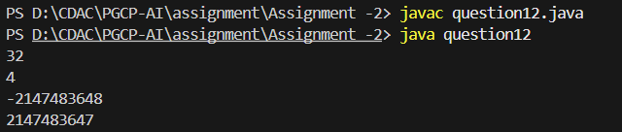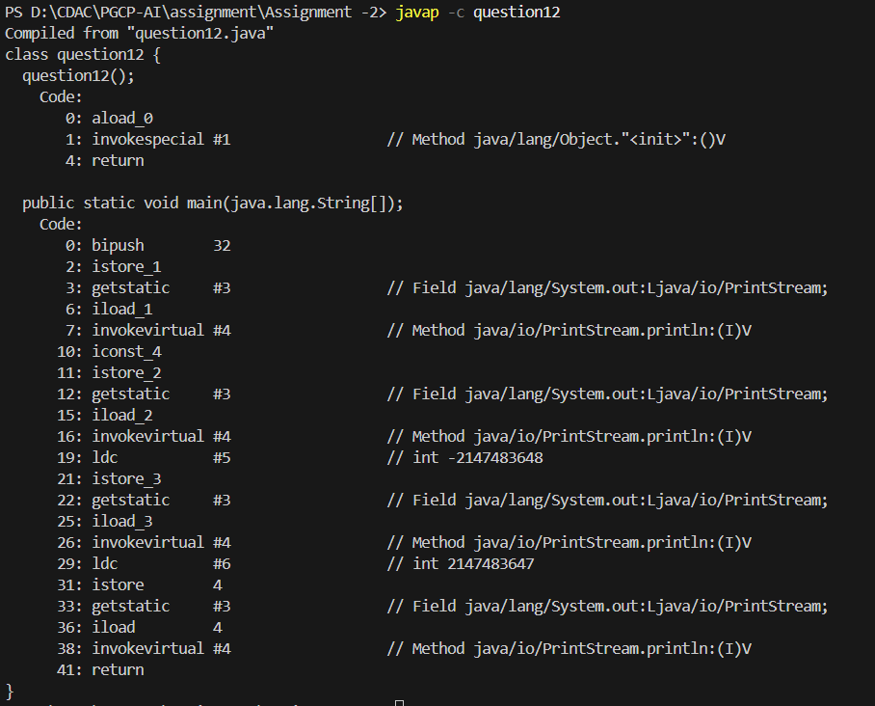

Question 16:
Code:
class question13 {

public static void main(String[] args){
int a = 89;
String b = Integer.toString(a);
System.out.println(b);
int c = 34;
String binary = Integer.toBinaryString(c);
String octal = Integer.toOctalString(c);
String hexadecimal = Integer.toHexString(c);

System.out.println(binary);
System.out.println(octal);
System.out.println(hexadecimal);
}
}
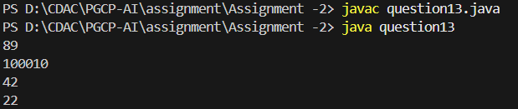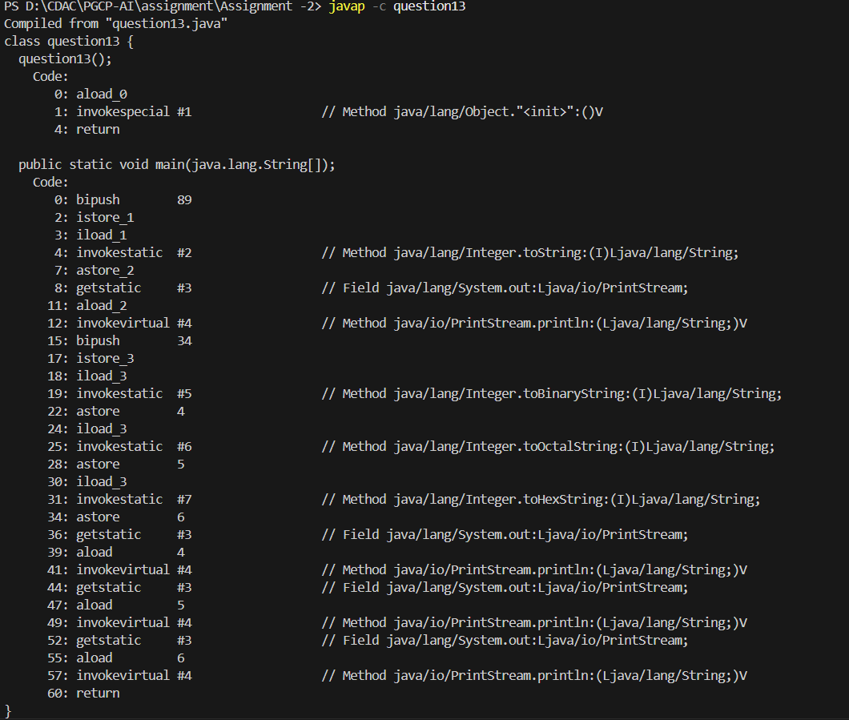

Question 18:
Code:
class question14 {

public static void main (String[] args){

int a = 45;
int b = 74;

int min = Integer.min(a, b);
int max = Integer.max(a, b);

int sum = Integer.sum(a, b);

System.out.println("Minimum Value: " + min);
System.out.println("Maximum Value: " + max);
System.out.println("Sum:" + sum);

}

}
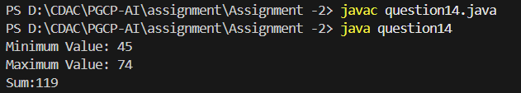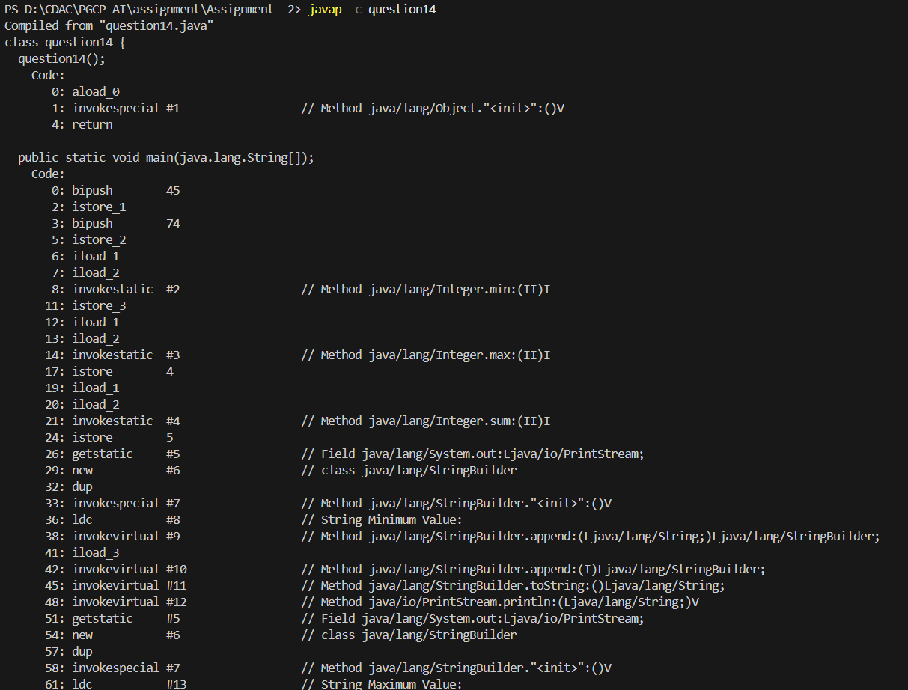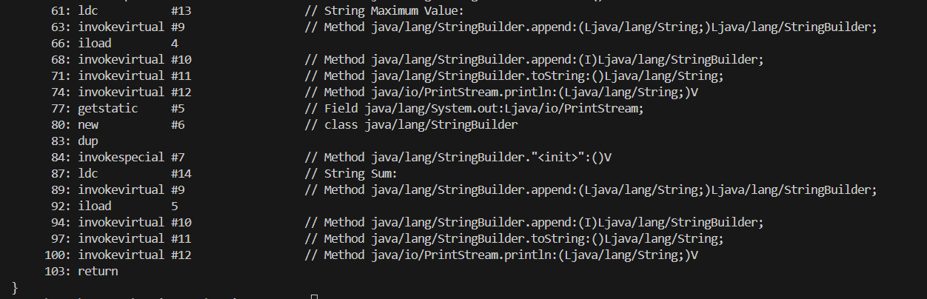

Question19:
Code:
class question15 {

public static void main (String[] args){

int bit = Long.SIZE;
int bytes = Long.BYTES;

long min = Long.MIN_VALUE;
long max = Long.MAX_VALUE;

System.out.println("Num of bits:" + bit);
System.out.println("Num of bytes:" + bytes);
System.out.println("Minimum Value:" + min);
System.out.println("Maximum value:" + max);

}

}
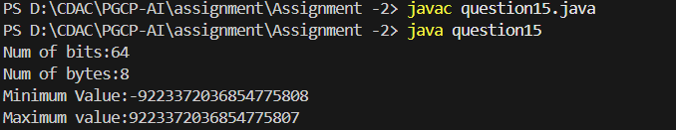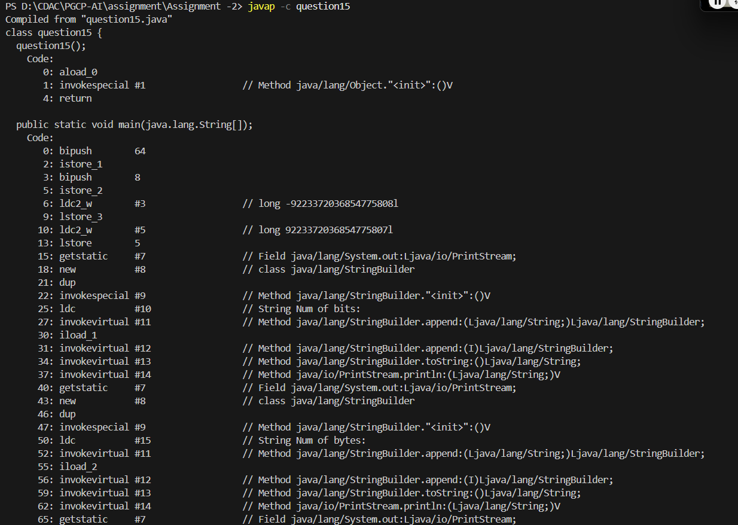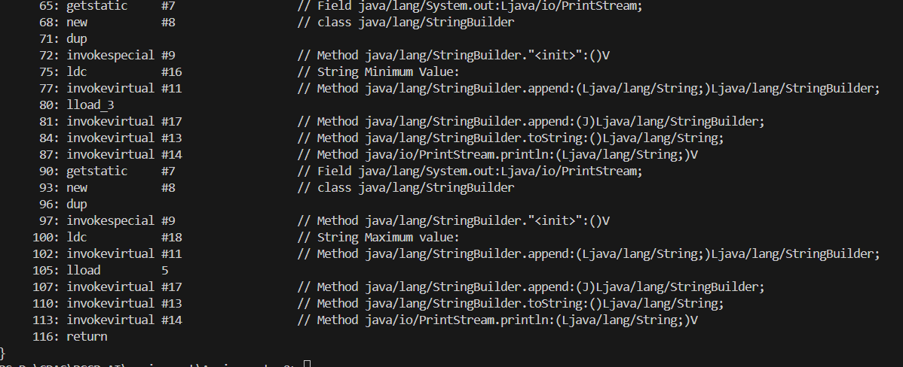

Question 20:
Code:
class question16 {

public static void main(String[] args){

long a = 1500000L;
String X = Long.toString(a);

System.out.println("Long to String:" + X);

String binary = Long.toBinaryString(a);
String octal = Long.toOctalString(a);
String hexadecimal = Long.toHexString(a);

System.out.println("Binary value:" + binary);
System.out.println("Octal Value:" + octal);
System.out.println("Hexadecimal Value:" + hexadecimal);

}

}
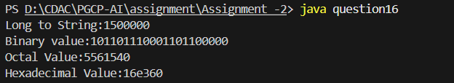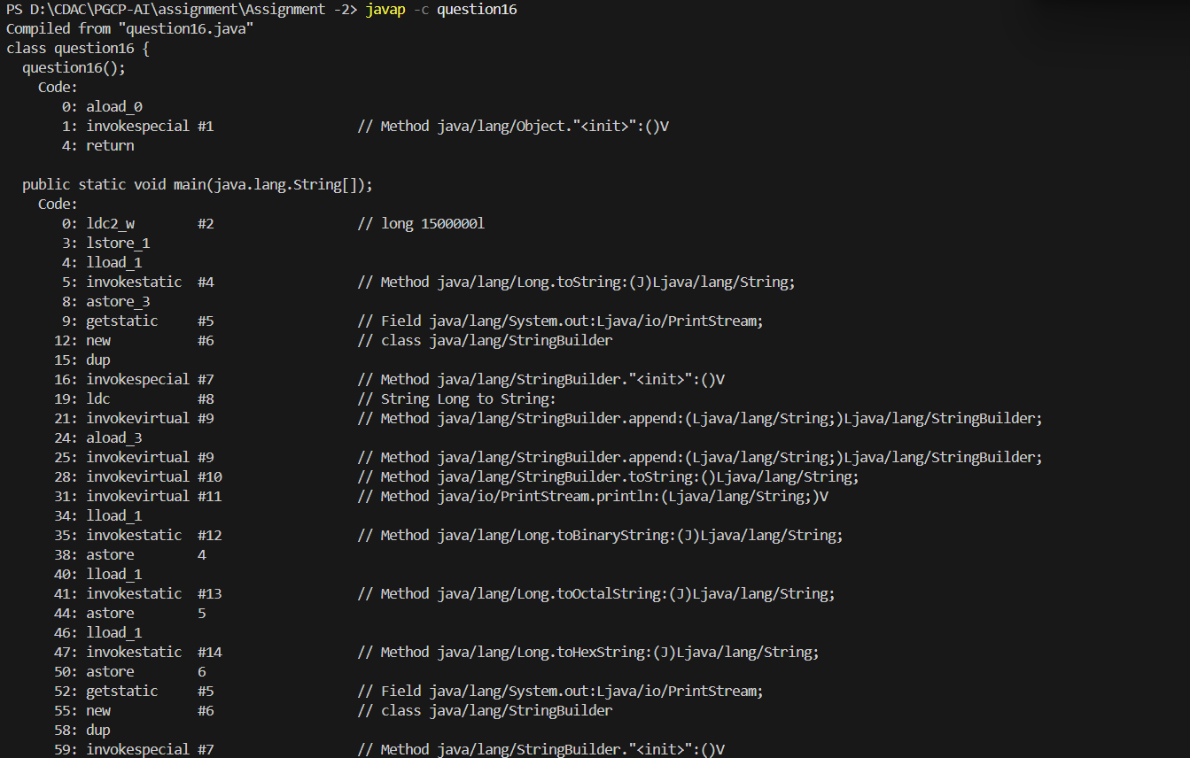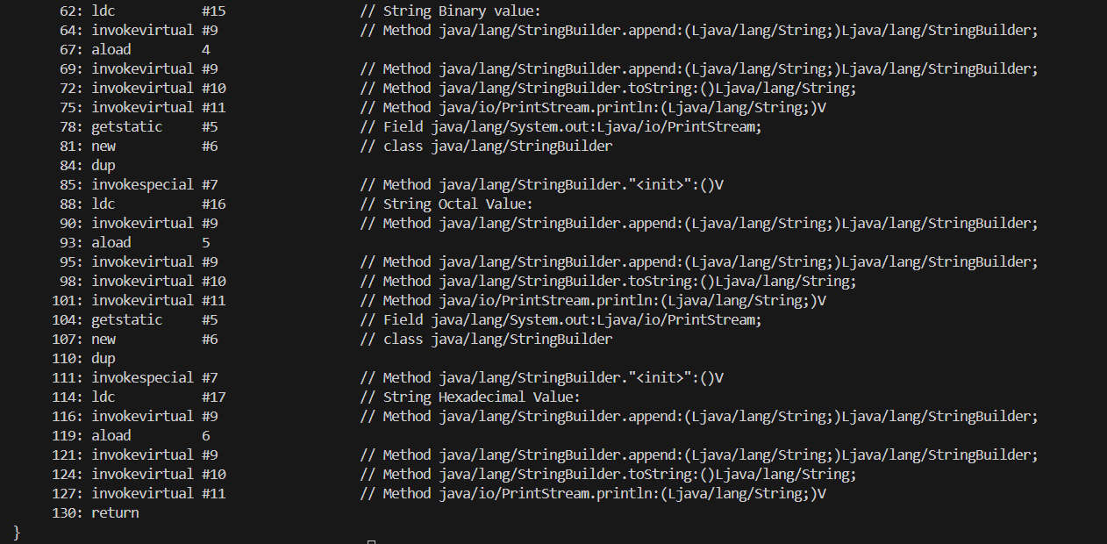

Question 22:
Code:
class question17 {

public static void main (String[] args){

long a = 7463493L;
long b = 249284L;

long min = Long.min(a, b);
long max = Long.max(a, b);
long sum = Long.sum(a, b);

System.out.println("Minimum: " + min);
System.out.println("Maximum: " + max);
System.out.println("Sum: " + sum);
}

}

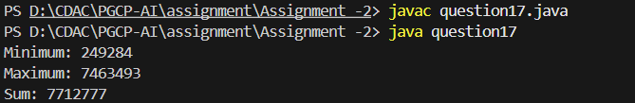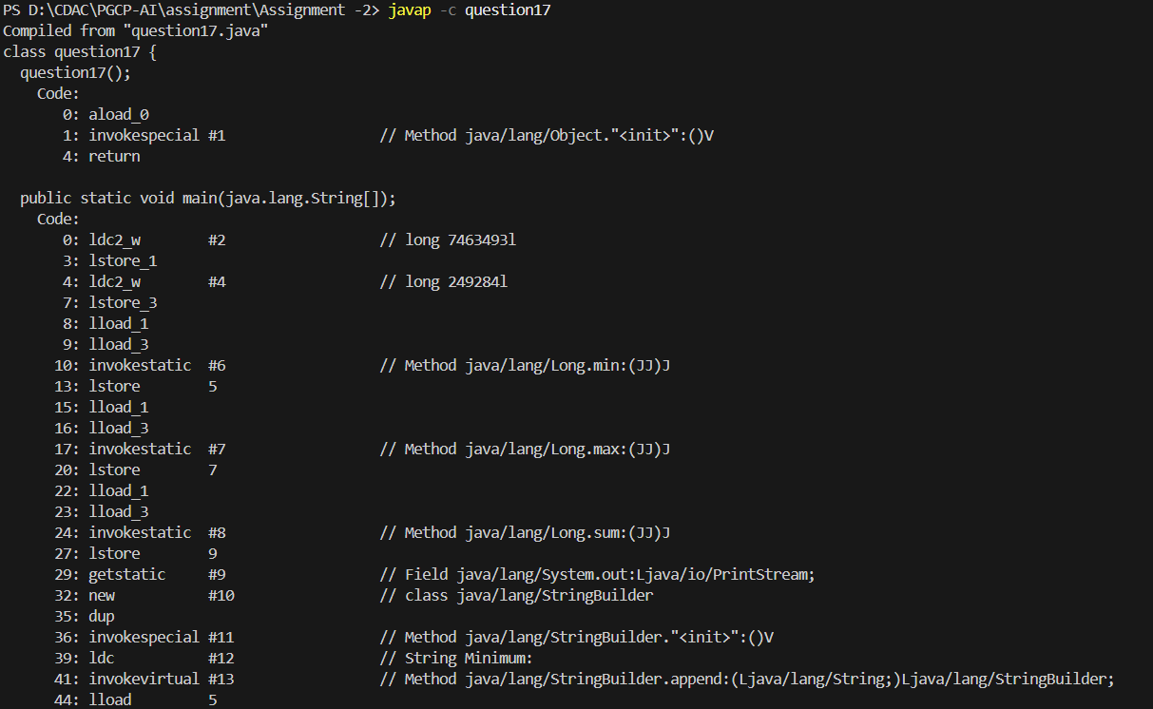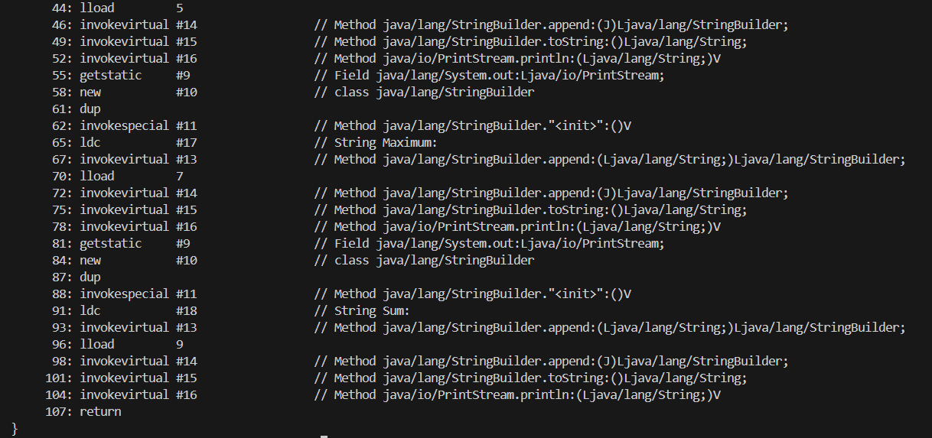

Question 23:
Code:
class question18 {

public static void main (String[] args){

int bit = Float.SIZE;
int bytes = Float.BYTES;
float min_value = Float.MIN_VALUE;
float max_value = Float.MAX_VALUE;

System.out.println("Num of bit: " + bit);
System.out.println("Num of bytes: " + bytes);
System.out.println("Minimum Value: " + min_value);
System.out.println("Maximum Value: " + max_value);

}

}
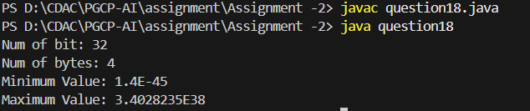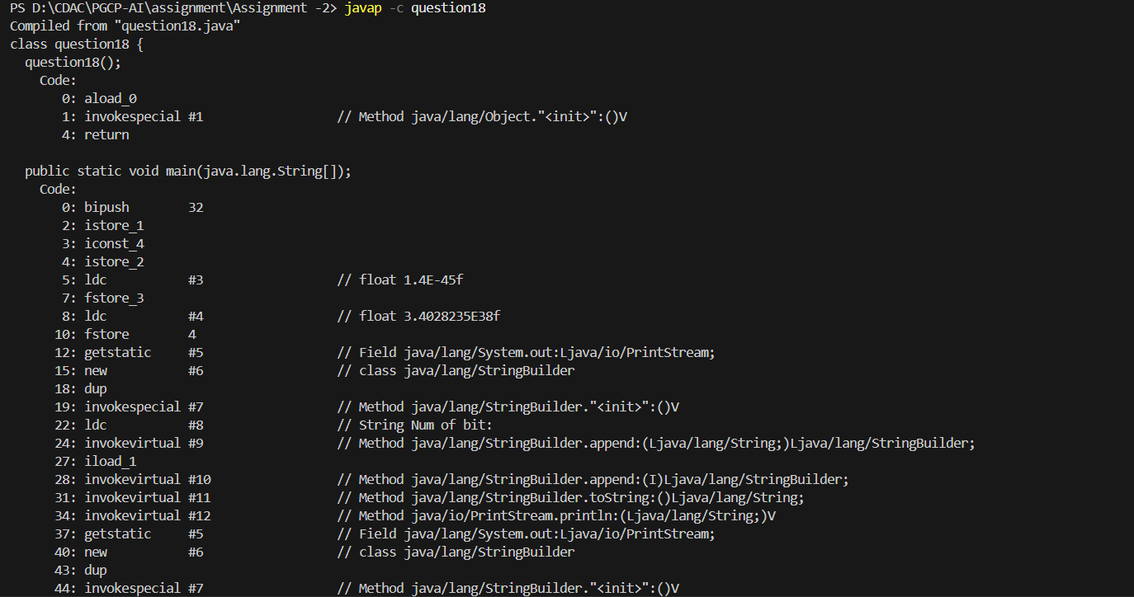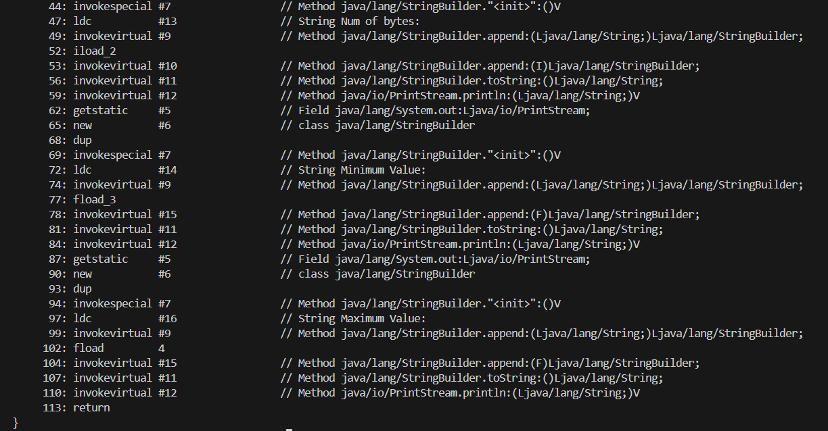

Question 24:
Code:
class question19 {

public static void main(String[] args){

float A = 3.84f;

String B = Float.toString(A);
String C = Float.toHexString(A);

System.out.println("Float to String: " + B);
System.out.println("Float to Hexadecimal: " + C);

}

}
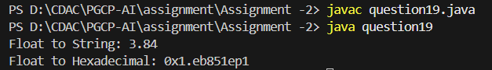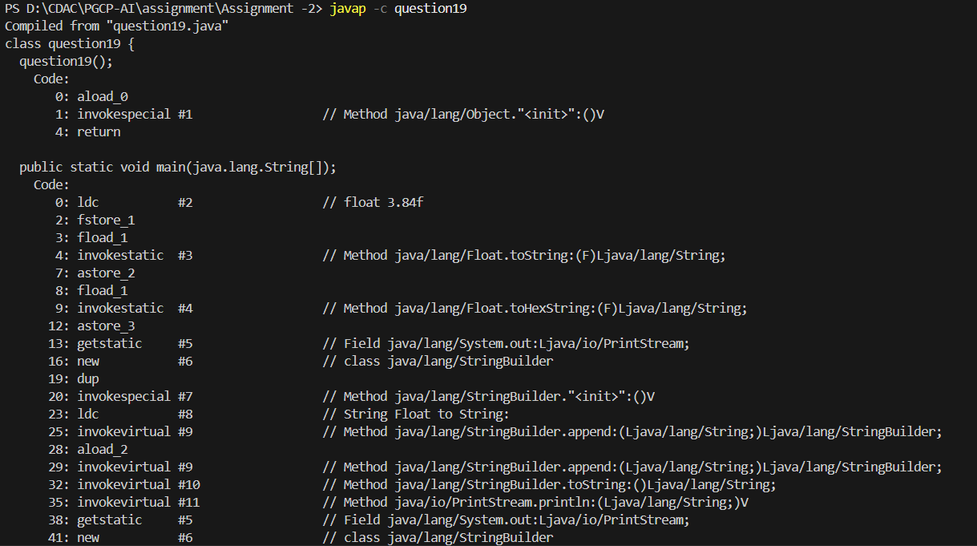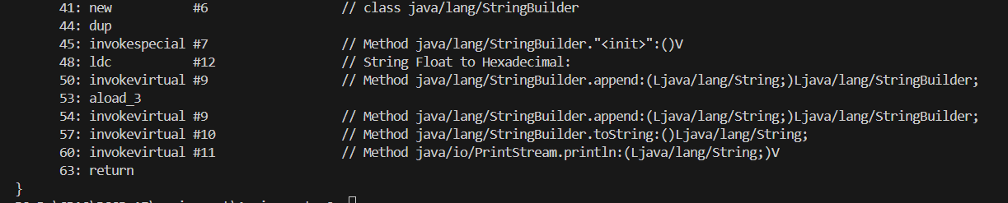

Question 26:
Code:
class question20 {

public static void main (String[] args){

float F1 = 3.25f;
float F2 = 6.37f;

float Min_Value = Float.min(F1, F2);
float Max_Value = Float.max(F1, F2);

float sum = Float.sum(F1, F2);

System.out.println("Minimum Value:" + Min_Value);
System.out.println("Maximum Value:" + Max_Value);
System.out.println("Sum:" + sum);

}

}

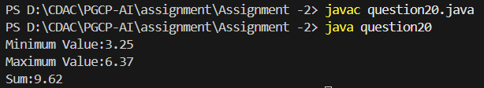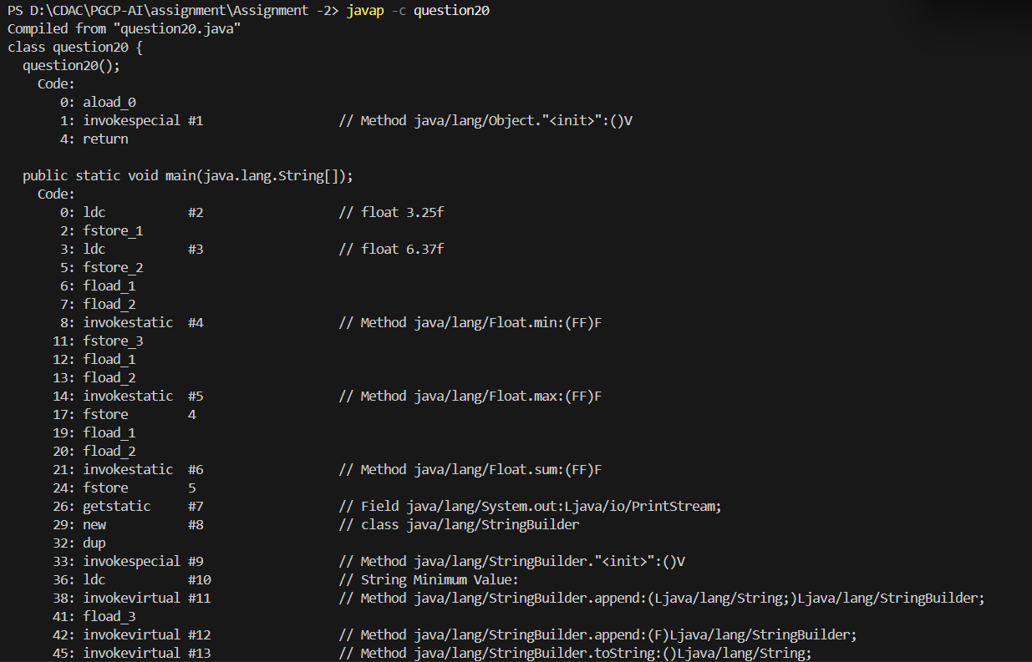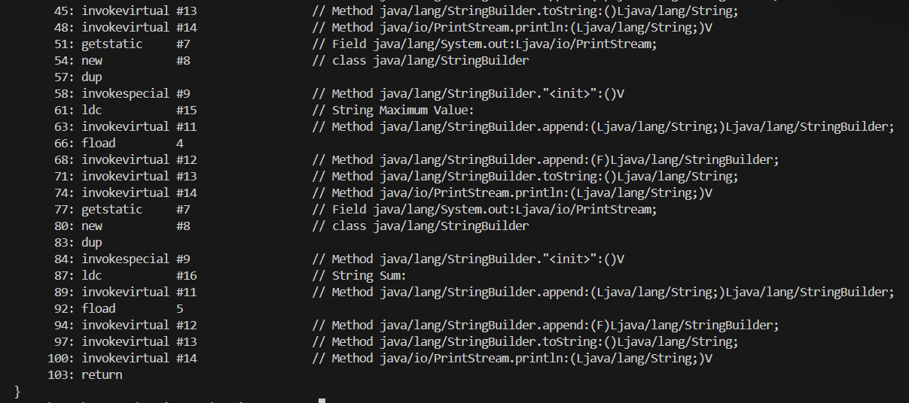

Question 27:
Code:
class question21 {

public static void main (String[] args){

int bit = Double.SIZE;
int bytes = Double.BYTES;
double min_value = Double.MIN_VALUE;
double max_value = Double.MAX_VALUE;

System.out.println("Bit Value:" +bit);
System.out.println("Byte Value:" + bytes);
System.out.println("Minimum Value:" + min_value);
System.out.println("Maximum Value:" + max_value);
}

}
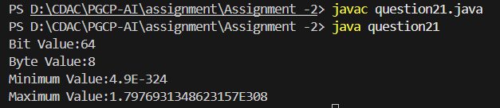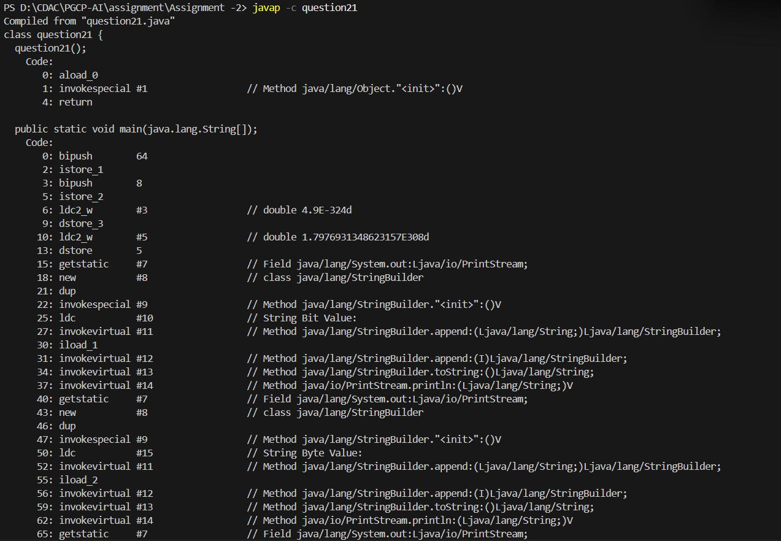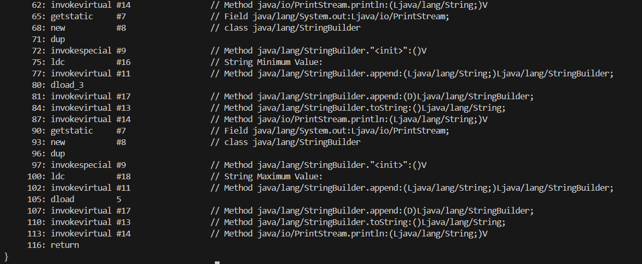

Question 28:
Code:
class question22 {

public static void main (String[] args){

double A = 4.8;

String Num = Double.toString(A);
long bits = Double.doubleToLongBits(A);

String binary = Long.toBinaryString(bits);
String octal = Long.toOctalString(bits);
String hexdecimal = Long.toHexString(bits);

System.out.println("Double to string value:" + Num);
System.out.println("Binary Value:" +binary);
System.out.println("Octal Value:" + octal);
System.out.println("Hexadecimal Value:" + hexdecimal);

}

}
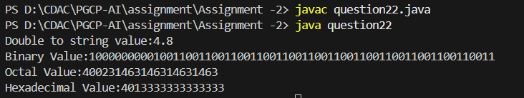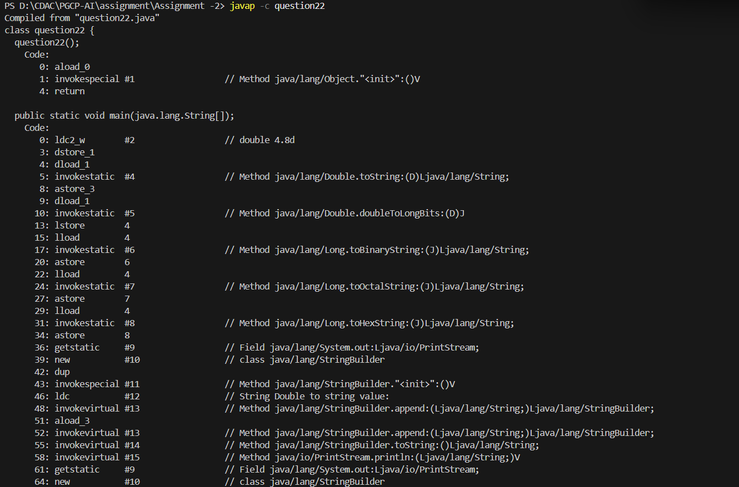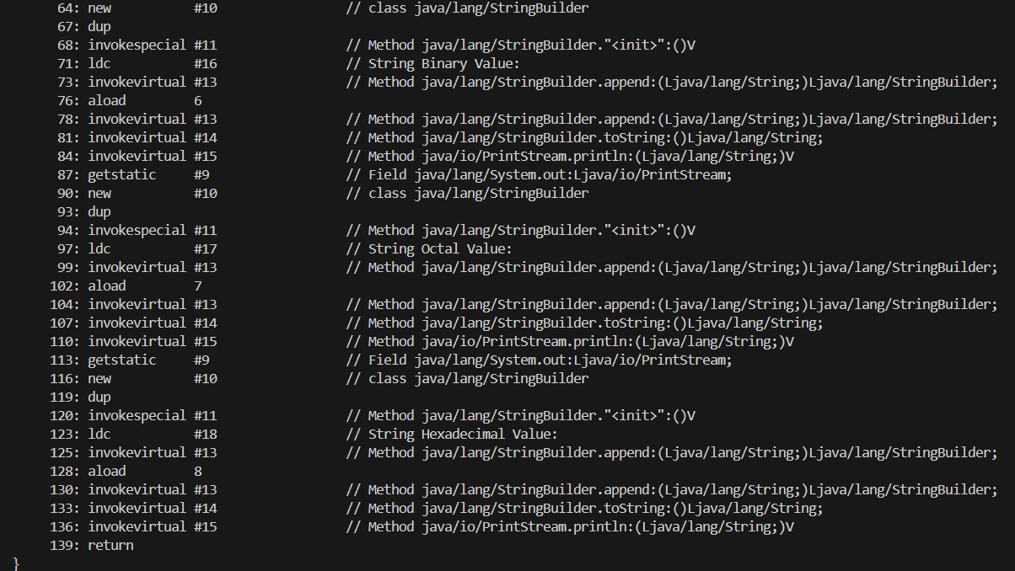

Question 30:
Code:
class question23 {

public static void main(String[] args){

double D1 = 3.53535;
double D2 = 6.33434;

double min_value = Double.min(D1, D2);
double max_value = Double.max(D1, D2);
double sum = Double.sum(D1, D2);

System.out.println("Minimum Value:" + min_value);
System.out.println("Maximum Value:" + max_value);
System.out.println("Sum:" + sum);
}

}

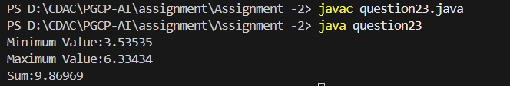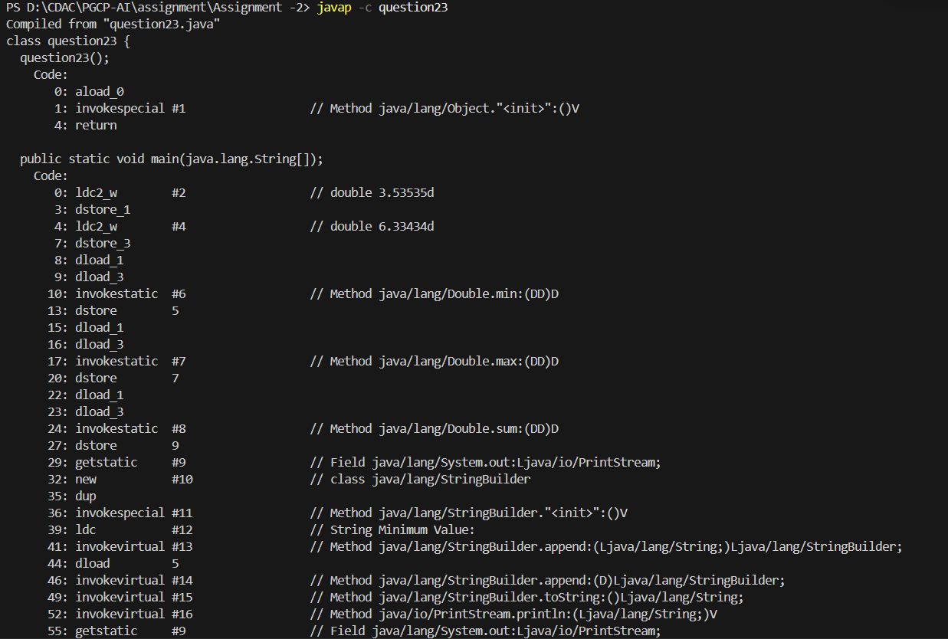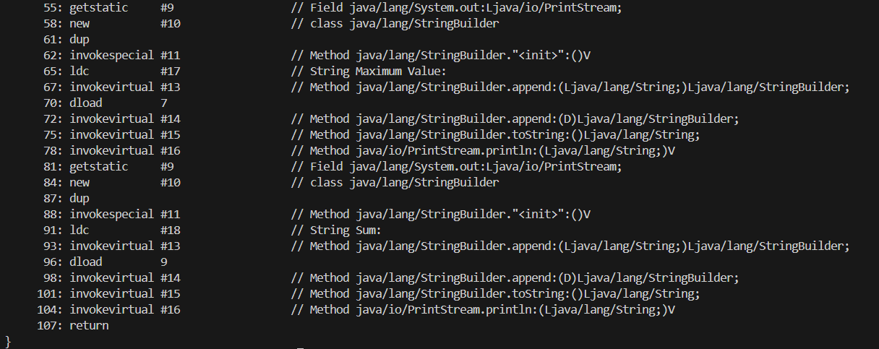

Question 6b:
Code:
class question25 {

public static void main(String[] args){
boolean B1 = true;
Boolean B2 = Boolean.valueOf(B1);

System.out.println(B2);
}

}

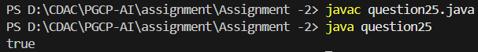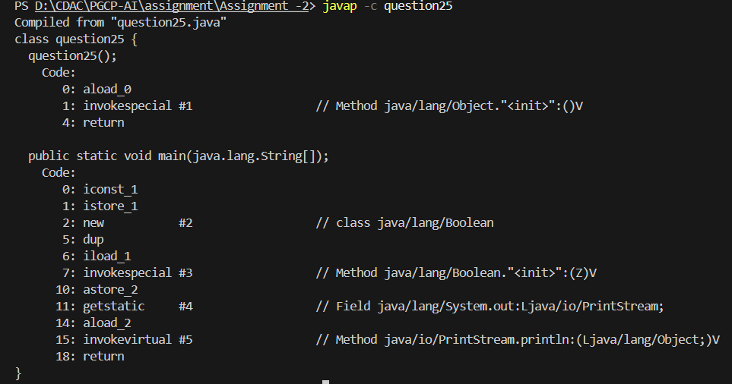

Question 6d:
Code:
class question26 {
public static void main(String[] args){

String a = "priyansu";

Boolean b = Boolean.valueOf(a);

System.out.print(b);

}
}

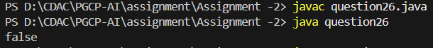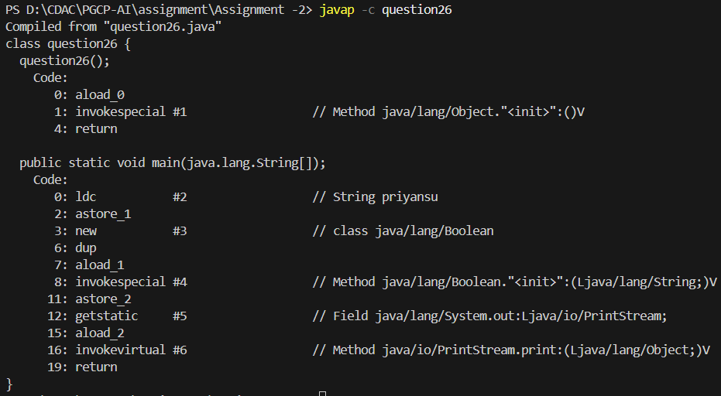

Question 8b:
Code:
class question27 {

public static void main(String[] args){

byte b = 23;
Byte c = Byte.valueOf(b);

System.out.println(c);

}

}
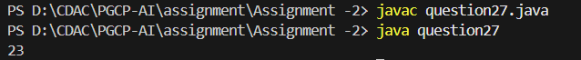

Question 9:
Code:
class question28 {
public static void main(String[] args) {

Byte s1 = Byte.valueOf((byte) 120);

byte b = s1.byteValue();
short s = s1.byteValue();
int i = s1.intValue();
long l = s1.longValue();
float f = s1.longValue();
double d = s1.longValue();
System.out.println("byte: " +b);
System.out.println("short: " +s);
System.out.println("int: " +i);
System.out.println("long: " +l);
System.out.println("float: " +f);
System.out.println("double: " +d);
}
}
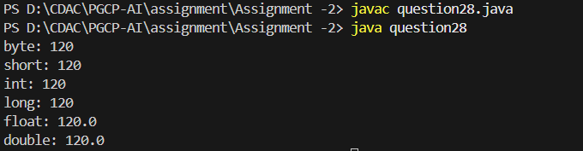

Question 8C:
Code:
class question29 {

public static void main(String[] args){

String A = "42";
Byte B = Byte.valueOf(A);

System.out.println("Byte Instance: " +B);

}

}
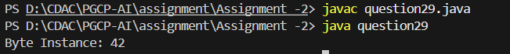

Question 13B;
Code:
class question30 {

public static void main(String[] args) {

short s1 = 34;
Short s2 = Short.valueOf(s1);

System.out.println(s2);

}

}
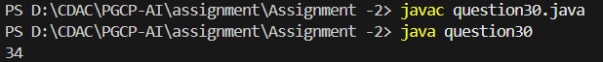

Question 13C;
Code:
class question31 {

public static void main(String[] args) {

String A1 = "342";

short S1 = Short.parseShort(A1);

System.out.println("Short Instance: " + S1);

}

}

Question 14:
Code:
class question32 {

public static void main(String[] args) {

Short S1 = Short.valueOf((short)93);

byte b = S1.byteValue();
short s = S1.shortValue();
int i = S1.intValue();
long l = S1.longValue();
float f = S1.floatValue();
double d = S1.doubleValue();

System.out.println("Byte: " +b);
System.out.println("Short: " +s);
System.out.println("Int: " +i);
System.out.println("Long: " +l);
System.out.println("Float: " +f);
System.out.println("Double: " +d);

}

}

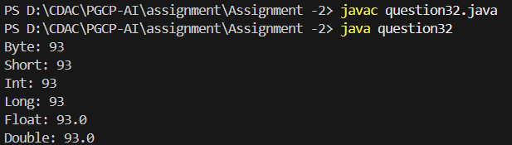

Question 16b:
Code:
class question33 {

public static void main(String[] args) {

int a = 45;

Integer b = a;

System.out.println(b);

}

}
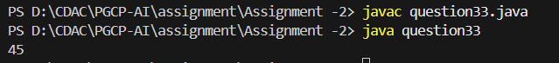

Question 16c:
Code:
class question34 {

public static void main(String[] args) {

String ab = String.valueOf(83);

Integer D = Integer.valueOf(ab);

System.out.println(D);

}

}

Question 17:
Code:
class question35 {

public static void main(String[] args) {
Integer A = Integer.valueOf(83);

byte b = A.byteValue();
short s = A.shortValue();
int i = A.intValue();
long l = A.longValue();
float f = A.floatValue();
double d = A.doubleValue();

System.out.println("Byte: " +b);
System.out.println("Short: " +s);
System.out.println("Integer: " +i);
System.out.println("Long: " +l);
System.out.println("Float: " +f);
System.out.println("Double: " +d);

}

}
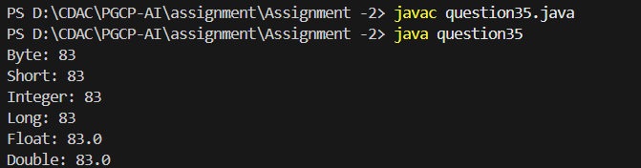
Question 20 B & C;
Code:
class question36 {

public static void main(String[] args) {
long X = 1495500L;
Long L = Long.valueOf(X);

System.out.println("Long value into Long Instance:" +L);

String S1 = "342";
Long L1 = Long.valueOf(S1);

System.out.println("String Instance to Long Instance: " +L1);

}

}
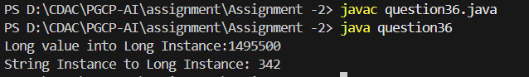

Question 21:
Code:
class question37 {

public static void main(String[] args){

Long L1 = Long.valueOf(642392L);

byte b = L1.byteValue();
short s = L1.shortValue();
int i = L1.intValue();
long l = L1.longValue();
float f = L1.floatValue();
double d = L1.doubleValue();

System.out.println("Byte:" +b);
System.out.println("Short:" +s);
System.out.println("Int:" +i);
System.out.println("Long:" +l);
System.out.println("Float:" +f);
System.out.println("Double:" +d);
}
}
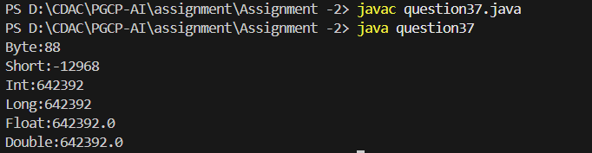
Question 24 B & C;
Code:
class question38 {

public static void main(String[] args) {

float F1 = 43.43f;

Float F2 = Float.valueOf(F1);

System.out.println(F2);

String S1 = String.valueOf("244");

Float F3 = Float.valueOf(S1);

System.out.println(F3);
}
}
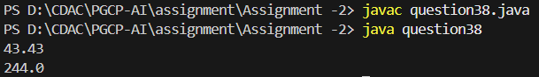

Question 25:
Code:
class question39 {

public static void main(String[] args) {

Float F1 = Float.valueOf(75.85f);

byte b = F1.byteValue();
short s = F1.shortValue();
int i = F1.intValue();
long l = F1.longValue();
float f = F1.floatValue();
double d = F1.doubleValue();

System.out.println("Byte:" +b);
System.out.println("Short:" +s);
System.out.println("Int:" +i);
System.out.println("Long:" +l);
System.out.println("Float:" +f);
System.out.println("Double:" +d);
}
}
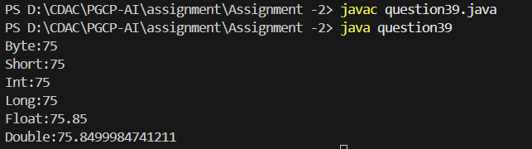
Question 28 B & C;
Code:
class question40 {

public static void main(String[] args) {

double D1 = 123;
double D2 = Double.valueOf(D1);

System.out.println(D2);

String S1 = "232";
double D3 = Double.valueOf(S1);

System.out.println(D3);

}

}
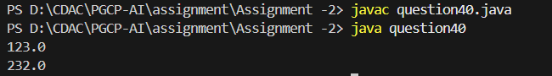

Question 29:
Code:
class question41 {

public static void main(String[] args) {
Double D1 = Double.valueOf(324.3);

byte b = D1.byteValue();
short s = D1.shortValue();
int i = D1.intValue();
long l = D1.longValue();
float f = D1.floatValue();
double d = D1.doubleValue();

System.out.println("Byte:" +b);
System.out.println("Short:" +s);
System.out.println("Int:" +i);
System.out.println("Long:" +l);
System.out.println("Float:" +f);
System.out.println("Double:" +d);
}

}
